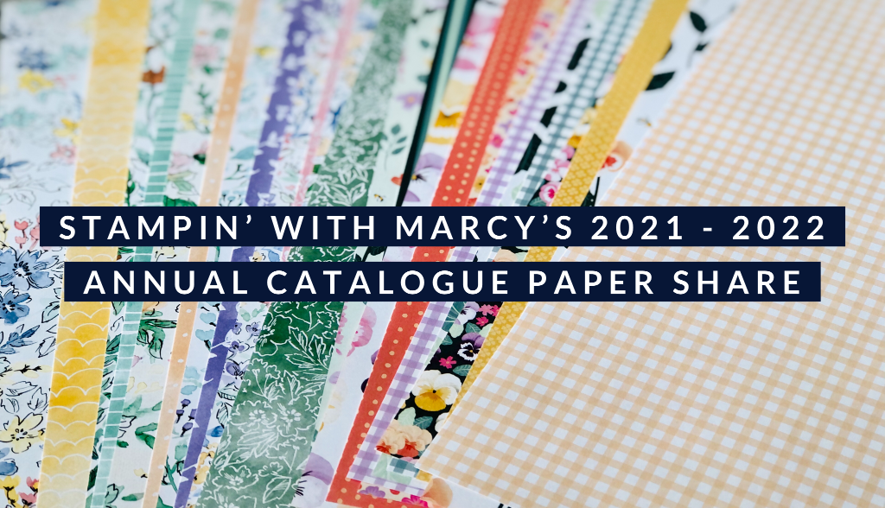
The new Stampin’ Up! 2021 - 2022 Annual Catalogue has 10 new gorgeous and fun Designer Series Paper packages!
I am offering my Paper Share once again for you to get a taste of each package at an affordable price!
Each share consists of 4 people, below is the list of Designer Series Paper and how many sheets from each package you will receive;
- Beauty Of The Earth – 12 pieces  - Bloom Where You’re Planted – 12 pieces  - Expressions In Ink Specialty – 12 pieces  - Hand Penned – 12 pieces  - You’re A Peach – 12 pieces | - In The Wild – 12 pieces  - Pansy Petals – 12 pieces  - Sweet Symmetry – 12 pieces  - Tidings Of Christmas – 12 pieces  - Simply Elegant Specialty – 12 pieces

Each Share receives 120 pieces of 6” x 6” Designer Series Paper
The Cost of each share is $52 for Local Porch Pickup, add on $20 for Priority Post to be mailed directly to you. Payment is by E-transfer (marcy@denning.ca) or Cash once I notify you the Share is full
As always, I will include a Thank You Gift for taking part in my Paper Share
Hugs,
Marcy

