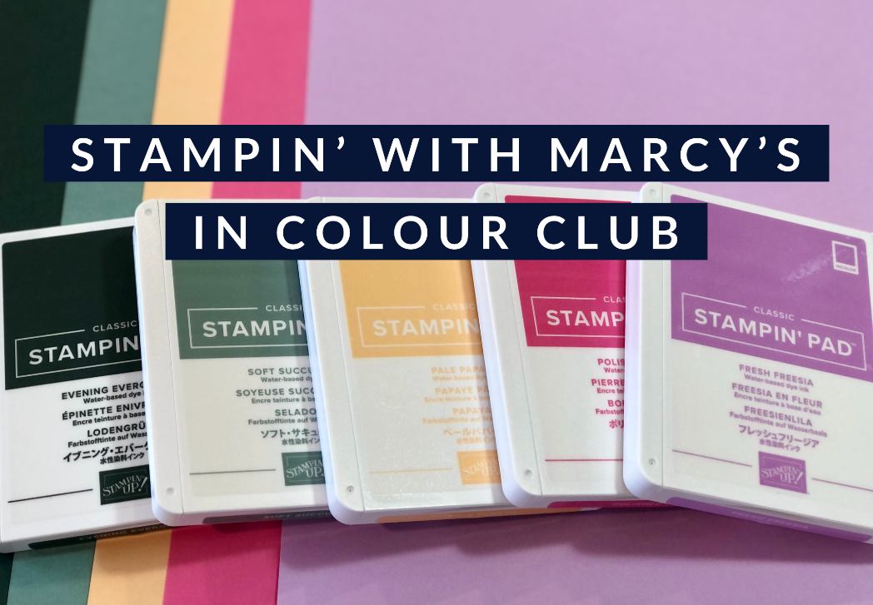

2021 Stampin’ with Marcy’s In Colour Club
May 2021 – September 2021
Do you want to build your collection of the new 2021-2023 In Colours? Join my new In Colour Club! Each month, you will receive a variety of products for one of the colours, each month featuring a different colour
Each month you will receive:
1 pack of cardstock (24 sheets), 1 roll of 3/8” Open Weave Ribbon, 1 ink pad, 1 ink refill, 1 Stampin’ Write Marker, eight 6” x 6” DSP pieces and a hand stamped card featuring your colour of the month
One month you will be the Host and gain the Host Rewards!
Details:
5 people per club
Cost: $53 for local Porch Pick up, add $20 for Priority Post if you are not local, you can live anywhere in Canada and be a part of my In Colour Club
Payment is E-Transfer (marcy@denning.ca) or Cash only; payment is due before the 1st of each month (I will send out a reminder)

